Joel Lantigua

Linux Administrator

Health script CentOS

11/28/22

CentOS health script

After the script was sent to my CentOS server I then logged into root on my CentOS server by using  **su – root**. Once I was in root I then was able to use **ls**  command under the Monitor directory and see that my health script was successfully sent. I then used **nano health.sh** to change one thing in my script which was the second command I added. So instead of having **cat /var/log/auth.log** I changed the “**auth.log”** to **secure** because centos don’t have auth.log command instead its named **secure.** So the command would be **cat /var/log/secure** this will show the Authorized logs on my CentOS server, then I was able to save and exit. Next, I ran the script by using  **./health.sh**

After using the command ./health.sh to run my script you can see in the screenshot below that my script successfully worked after changing “auth.log” to “secure”. After running my script I used the **ls** command to see if my script also made the Lynis_Scan file which it did.

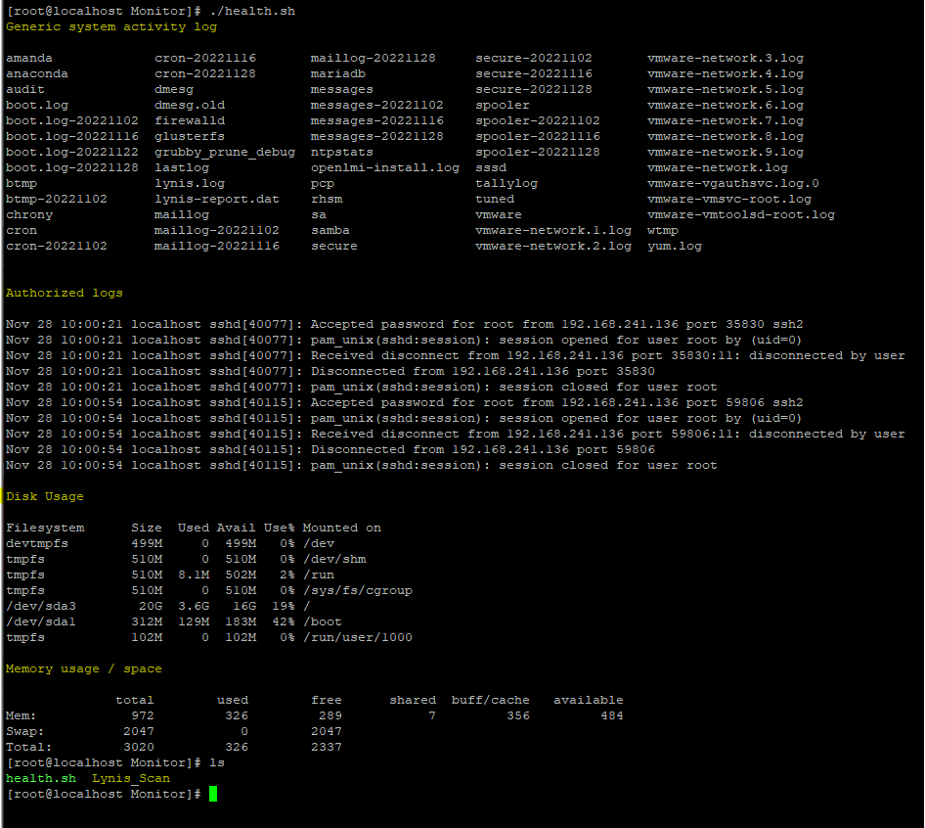

As you can see in the screenshot below that my script created the new Lynis_scan file. To view the file I sued the command **cat Lynis_Scan** this allowed me to view the report in the file my script created .Text
